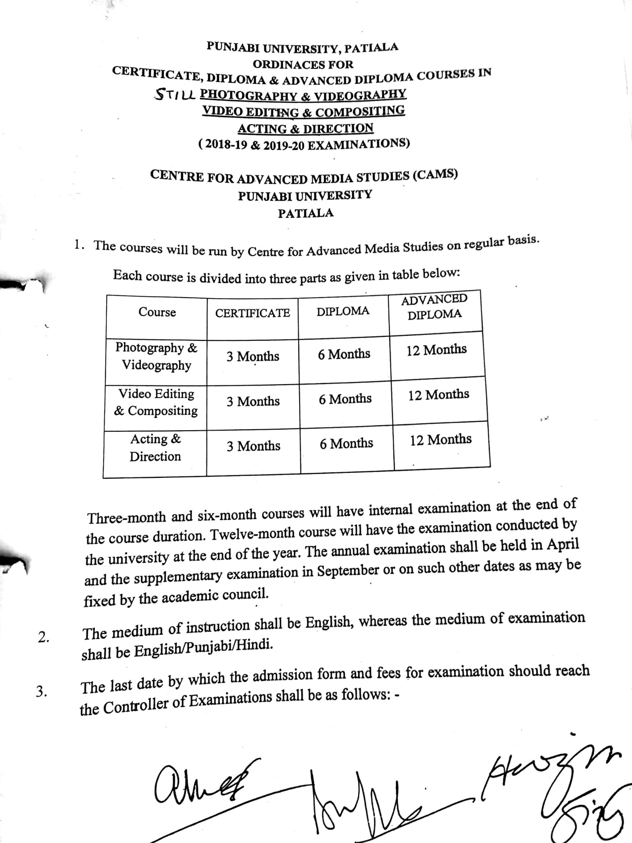

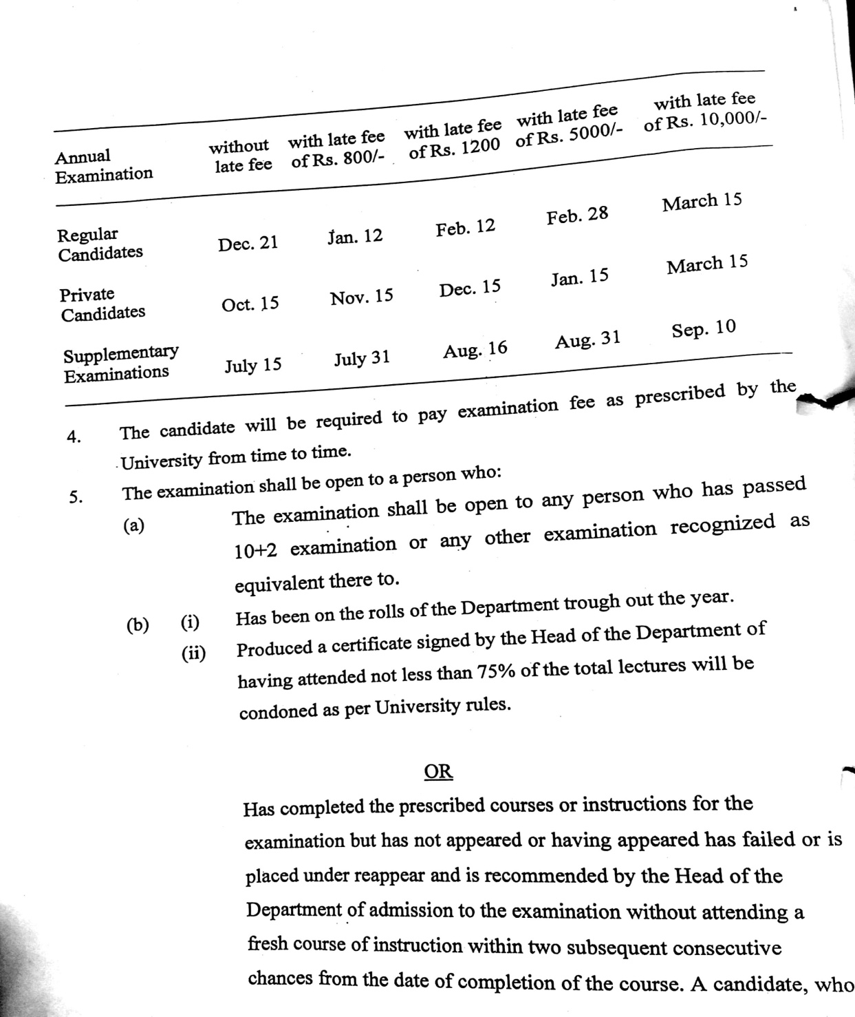

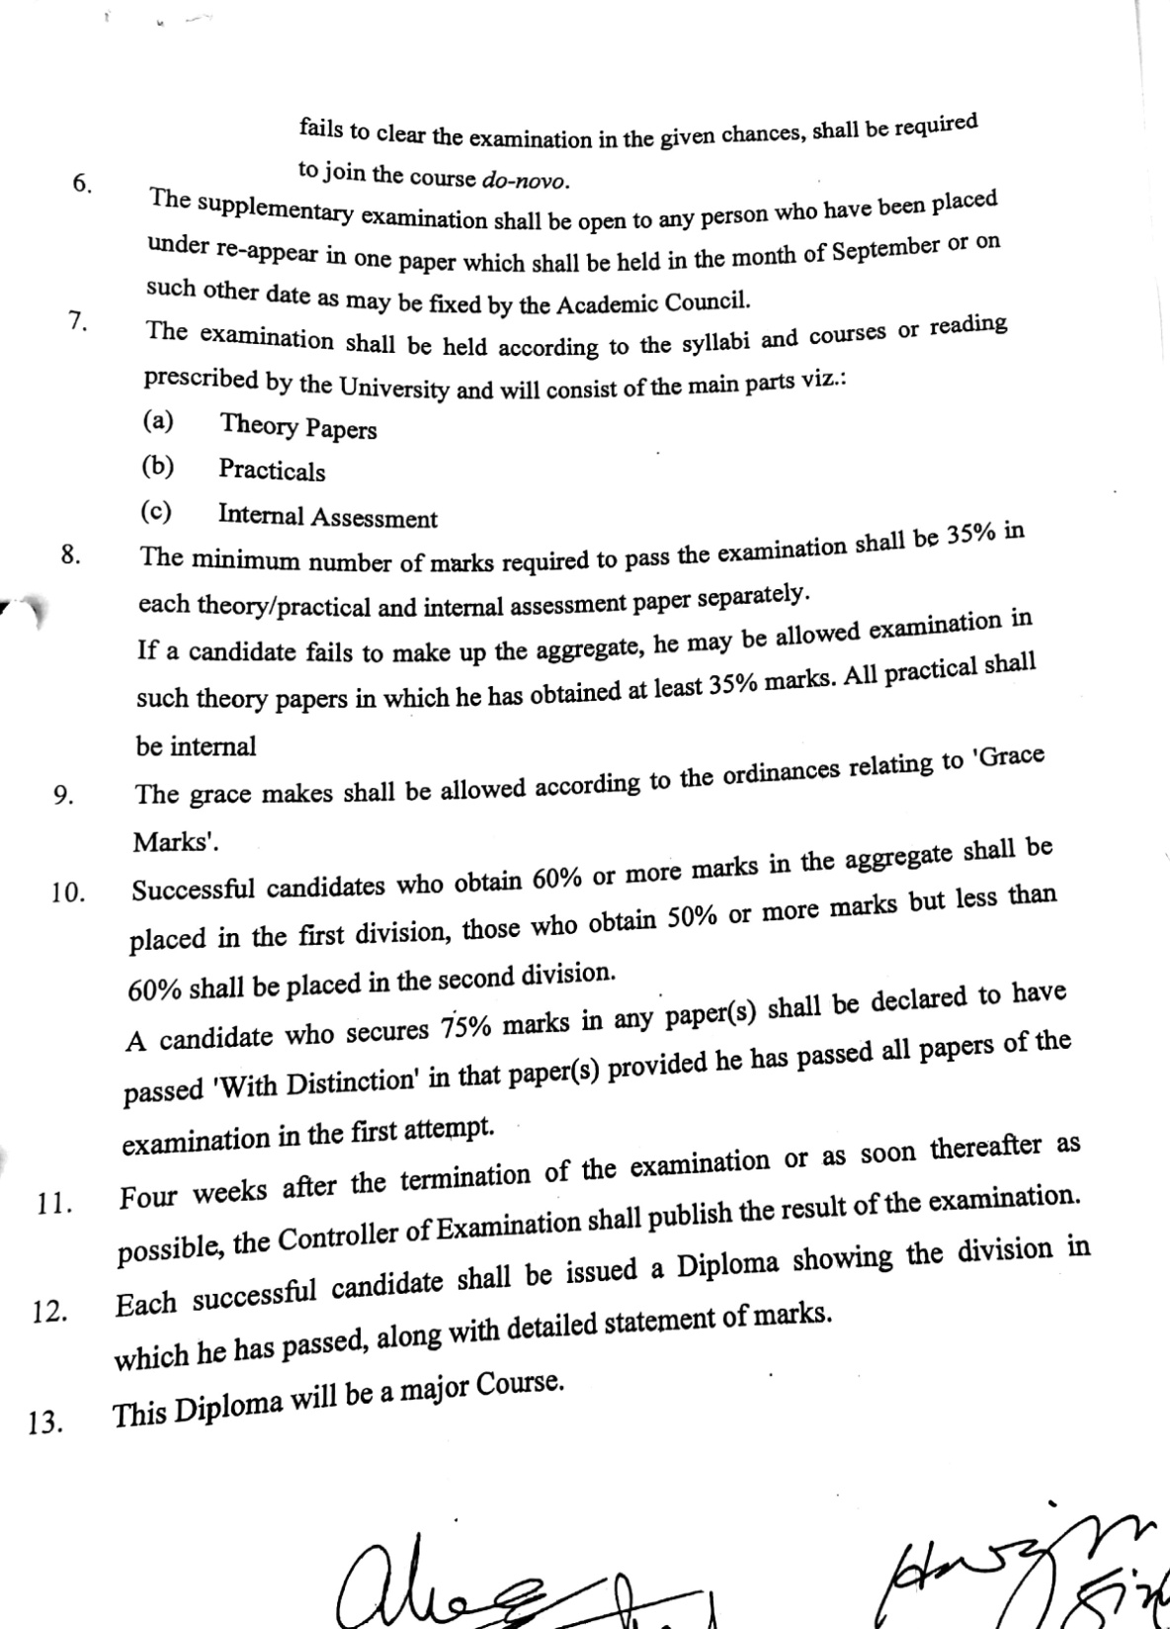

SYLLABUS

Short Term Evening Courses

SESSION: 2018–2019, 2019-2020
& 2020-21
VIDEO EDITING AND COMPOSITING
PAPER-Editing & Compositing (3 Months)

PAPER-Editing & Compositing (6 Months)

PAPER-Editing & Compositing (One Year)

PAPER-Editing & Compositing (3 Months)

Max. Marks: 100 Continuous Internal Evaluation 80 Marks
Pass Marks: 35 Internal Assessment 20 Marks

INSTRUCTIONS FOR THE CANDIDATES

Candidates will be required to submit assignments from each section and perform the tasks given by the teacher(s) during the entire period of the three months. Evaluation will be done on the basis of quality of assignments and viva voce. Each section will carry 10 marks.

Course Content
SECTION A
Understanding the basics: History of film editing, Introduction to digital video editing, Qualities of good video editor, Linear and non-linear editing. Principles of editing, Transitions, Screen Direction, 180 degree and 30 degree rule, Matching Angles, Eye-line, Continuity of Action,
SECTION B
Editing video: overview of editing application, creating a new project & the workspace, importing, capturing, and managing assets, working with clips and markers, the timeline panel & sequence, creating titles, credit rolls, and lower thirds, adding and arranging clips on a single audio/video pair of tracks, trimming and adjusting clips designing & inserting titles, editing video, applying video and audio transitions, working with video effects, introducing audio editing, working with audio effects, exporting your final project to the web, mobile devices, and tape.
Text and References
• Adobe Premiere Pro Classroom in a Book by Adobe Creative Team, Paperback, 1st edition
(2012)
• An Editor's Guide to Adobe Premiere Pro by Richard Harrington, Robbie Carman And Jeff I.
Greenberg, Paperback, 1st edition (2011)
• Nonlinear Editing: Media Mannel; Morris, Patrick, Published 1999 Focal Press
• Writing and Producing Television News: Gormly, Eric K, Ames, Iowa: Blackwell Publishing
• Fundamentals of Television Production: Donald, Ralph & Spann, T
• Editing Today: Smith, Ron F. & O'Connell, L.M, Blackwell Publishing
• Television Production Handbook: Zettl, Herbert Published 2005, Thomson Wadsworth

PAPER-Editing & Compositing (6 Months)

Max. Marks: 100 Continuous Internal Evaluation 80 Marks
Pass Marks: 35 Internal Assessment 20 Marks

INSTRUCTIONS FOR THE CANDIDATES

Candidates will be required to submit assignments from each section and perform the tasks given by the teacher(s) during the entire period of the three months. Evaluation will be done on the basis of quality of assignments and viva voce. Each section will carry 10 marks.

Course Content
Section A
Understanding the basics: history of film editing, introduction to digital video editing, qualities of good video editor, linear and non-linear editing. Principles of editing, transitions, screen direction, 180 degree and 30 degree rule, matching angles, eye-line, continuity of action, exploring techniques that can make or break the continuity between one shot and the next, techniques for connecting shots such as graphic match, rhythm, compression and expansion of time.
Section B
Editing video: overview of editing application, creating a new project & the workspace, importing, capturing, and managing assets, organizing media, essentials of video editing, working with clips and markers, the timeline panel & sequence, creating titles, credit rolls, and lower thirds, adding and arranging clips on a single audio/video pair of tracks, trimming and adjusting clips designing & inserting titles, editing video, applying video and audio transitions, working with video effects, performing color correction, introducing compositing (layering), animating motion effects, using keying effects, specialized compositing: adjustment layers and the track matte key effect, introducing audio editing, working with audio effects, exporting your final project to the web, mobile devices, and tape.
Text and References
• Adobe Premiere Pro Classroom in a Book by Adobe Creative Team, Paperback, 1st edition
(2012)
• An Editor's Guide to Adobe Premiere Pro by Richard Harrington, Robbie Carman And Jeff I.
Greenberg, Paperback, 1st edition (2011)
• Nonlinear Editing: Media Mannel; Morris, Patrick, Published 1999 Focal Press
• Writing and Producing Television News: Gormly, Eric K, Ames, Iowa: Blackwell Publishing
• Fundamentals of Television Production: Donald, Ralph & Spann, T
• Editing Today: Smith, Ron F. & O'Connell, L.M, Blackwell Publishing
• Television Production Handbook: Zettl, Herbert Published 2005, Thomson Wadsworth

PAPER-Editing & Compositing (One Year)

Max. Marks: 100 Theory: 60 Marks
Pass Marks: 35 Practical: 20 Marks
Time Allowed: 3 Hours Internal Assessment: 20 Marks

INSTRUCTIONS FOR THE PAPER-SETTER
The question paper will consist of three sections: A, B and C. Sections A and B will have four questions from the respective sections of the syllabus and will carry 10 marks each. Section C will consist of 10 short-answer type questions which will cover the entire syllabus uniformly and will carry 20 marks in all.

INSTRUCTIONS FOR THE CANDIDATES
Candidates are required to attempt two question each from the sections A and B of the question paper and the entire section C.

Course Content
Section A
Understanding the basics: History of film editing, Introduction to digital video editing, Qualities of good video editor, Linear and non-linear editing. Principles of editing, Transitions, Screen Direction, 180 degree and 30 degree rule, Matching Angles, Eye-line, Continuity of Action, Exploring techniques that can make or break the continuity between one shot and the next, Techniques for connecting shots such as graphic match, Rhythm, Compression and Expansion of time. Introduction to Digital Compositing techniques; Introduction to Compositing and After Effects: Fundamental concepts of Compositing, Introduction to the after effects Interface & Tools, Basic Animation: Fundamentals of animation, Keyframes & Transform properties
Section B
Editing video: overview of editing application, creating a new project & the workspace, importing, capturing, and managing assets, organizing media, essentials of video editing, working with clips and markers, the timeline panel & sequence, creating titles, credit rolls, and lower thirds, adding and arranging clips on a single audio/video pair of tracks, trimming and adjusting clips designing & inserting titles, editing video, applying video and audio transitions, working with video effects, performing color correction, introducing compositing (layering), animating motion effects, using keying effects, specialized compositing: adjustment layers and the track matte key effect, introducing audio editing, working with audio effects, exporting your final project to the web, mobile devices, and tape. Introduction to After Effects program layout & basics, Import Footage and Creating A Project, Work with Comps, Arranging and Compositing Layers in a Composition, Modifying and Animating layers and working with transform tools, Working with Text & Animating Text, creating shapes with motion, Working with Masks and mask animations, Applying Effects and Transitions, Green Screen editing in After Effects, exporting with transparency, exporting your final project.
Text and References
• Adobe Premiere Pro Classroom in a Book by Adobe Creative Team, Paperback, 1st edition
(2012)
• An Editor's Guide to Adobe Premiere Pro by Richard Harrington, Robbie Carman And Jeff I.
Greenberg, Paperback, 1st edition (2011)
• Nonlinear Editing: Media Mannel; Morris, Patrick, Published 1999 Focal Press
• Fundamentals of Television Production: Donald, Ralph & Spann, T
• Editing Today: Smith, Ron F. & O'Connell, L.M, Blackwell Publishing
• Television Production Handbook: Zettl, Herbert Published 2005, Thomson Wadsworth
• Adobe After Effects CS6 Classroom in a Book by Adobe Creative Team
• The Visual Effects Producer; Understanding the Art and Business of VFX by Charles Finance
and Susan Zwerman, Focal Press.
• The Visual Effects Arsenal, VFX solutions for the independent filmmaker by Bill Byrne; Focal press.
• Digital Compositing for Film & Video; Steve Wright, Focal Press

